**TO:** John Henry, Principal Owner and Director

**FROM:** Group 5, Analysts

**DATE:** November 5, 2019

**SUBJECT:** Liverpool Football Club Analysis Through CyberMetrics

In order to better provide recommendations for Liverpool during its resurgence, we as a group have conducted deep research and analysis on the team, its competitors, and players specifically. Based on our statistics and sources, although we saw prospective development on Liverpool and its team members, we realized that Liverpool has not been champions for the Premier League title since 1990 (Ogden, 2018), and it is undeniable that Liverpool experiences deficiencies to some extent, which prevent it from pursuing further success and resurgence. We expect that with our insightful and targeted recommendations toward the team and players, Liverpool will become stronger in future competitions and recapture the glory days of the eighties.

To help understand the future prospect of Liverpool and team members, we will first forecast team’s performance over the next two years, and then compare Liverpool with its three competitors, and last but not least, try to optimize team performance by advising how to adjust its players.

***Next Season Wins and Losses Forecast***

Based on the revised Poisson Model, we designed the following theoretical model:

*liverpoolwin = teamattack * teamfactor * plavgwin*

*liverpoollose = teamdefend * teamfactor * plavgloss*

*liverpooldraw = 1 - (liverpoolwin + liverpoollose)*

In the above model, *liverpoolwin*, *liverpoollose* , and *liverpooldraw* represent the winning, losing, and draw rate of Liverpool versus all the other teams participating in the Premier League. *teamattack* and *teamdefend* respectively stand for Liverpool’s attacking and defending parameter, while *teamfactor* represents Liverpool current year’s overall performance value (if it does not exist, replace it with last year’s overall potential value) divided by last year’s, and this predictor accounts for the trades, drafts and injures of team players. *plavgwin* and *plavgloss* stand forthe sum of each Premier League team’s average winning and losing rate.

Using statistics on Kaggle, we calculated 2019-2020 season Liverpool’s relatively winning, losing, and draw rate will be 86.08%, 2.87%, 11.06%, therefore we expect that Liverpool will win a very high percentage of games this season.

***Three Competitors Analysis***

Liverpool has three biggest competitors in history and at present:

* Chelsea: the rivalry between these two teams can be traced back to the mid-2000s, when Chelsea vs. Liverpool became the most bitter rivalry in English football. Recently, Chelsea's rise since 2003 has reflected Liverpool's decline, and although Liverpool is currently under resurgence, Chelsea's recent trophy haul is far greater than Liverpool's (Ogden, 2018).
* Manchester City: Liverpool vs. Manchester City has become the most anticipated game in English football during the past two years. The manager of Liverpool, Jurgen Klopp, and the manager of City, Pep Guardiola, are always put together to compare because they both are competitive coaches, but they encourage completely different footballing styles. Klopp emphasizes urgency, so his teams pass the ball effectively, while Guardiola is more cautious and patient and his teams are often very good at transitions (Cox, 2016).
* Manchester United: is English football's most successful and best-supported club. There were 38 league titles (United 20, Liverpool 18) and eight European Cup/Champions League titles (United three, Liverpool five) between them (Ogden, 2018).

According to all the historical data of Liverpool versus its three competitors from the Premier League, we could tell Liverpool’s performance against three other teams:

|  |  |  |  |  |  |  |
| --- | --- | --- | --- | --- | --- | --- |
| Liverpool | Chelsea | | Manchester City | | Manchester United | |
| Wins | 21 | 38.18% | 19 | 43.18% | 14 | 25.45% |
| Losses | 25 | 45.45% | 9 | 20.45% | 28 | 50.91% |
| Draws | 9 | 16.36% | 16 | 36.36% | 13 | 23.64% |
| Total | 55 | 100% | 44 | 100% | 55 | 100% |

Seen from the above table, in the 44 games between Liverpool and Manchester City, Liverpool won 19 games. The winning rate is 43.18%, which is higher than the winning rate against Chelsea and Manchester United. Liverpool tended to lose against Chelsea and Manchester United in the past, with 45.45% and 50.91% losing rate.

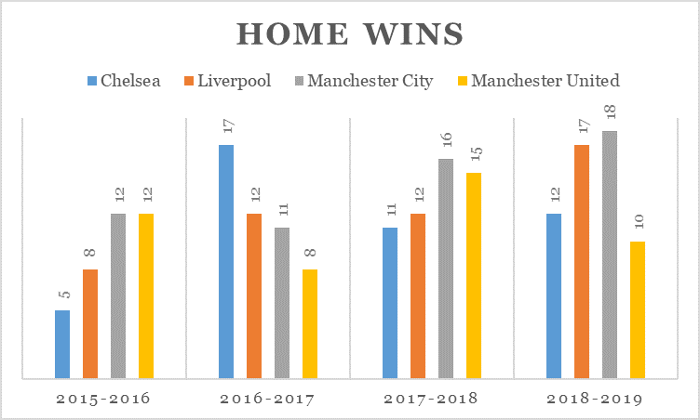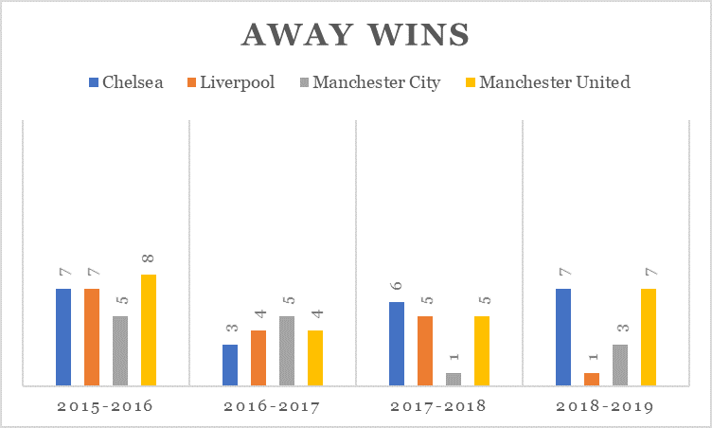

Every team in the Premier League plays 19 games each season, both on the road and at home. We can see from the charts that from 2015 to 2019, Liverpool are getting back its initiative at home, from 8 wins in 2015-2016 season to 17 wins of 19 games last season. Manchester City is strong at home in the past season and it won nearly every game at home except for one game. For this reason, we chose Manchester City as Liverpool’s strongest competitor. The other two teams’ performance are pretty unstable at home.

* On the other hand, Liverpool is actually getting weak on the road compared to the other three teams. It only won one of the 19 away games last season. Its failure on the road could be attributed to the injury of the team's key player and from the simplicity of the tactics.

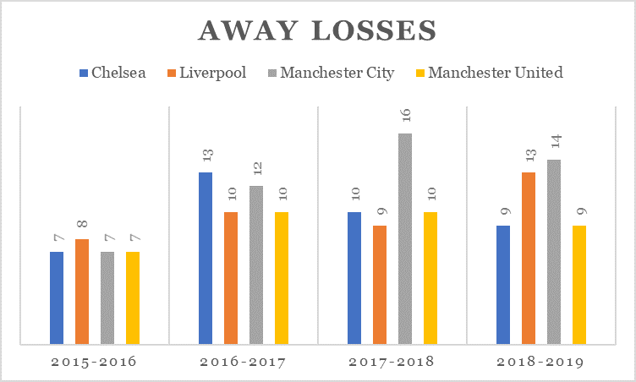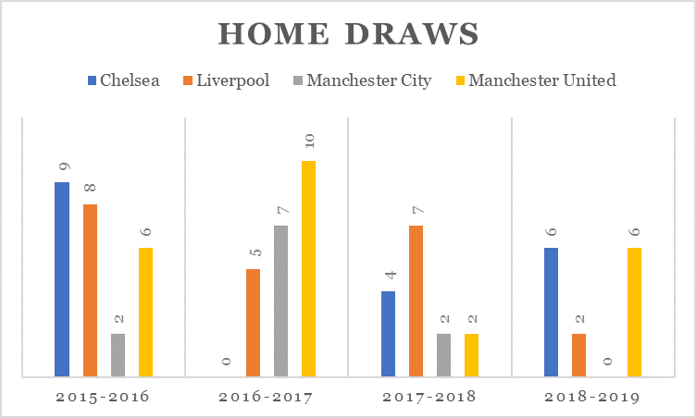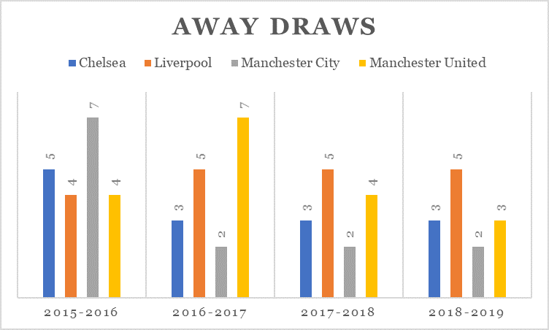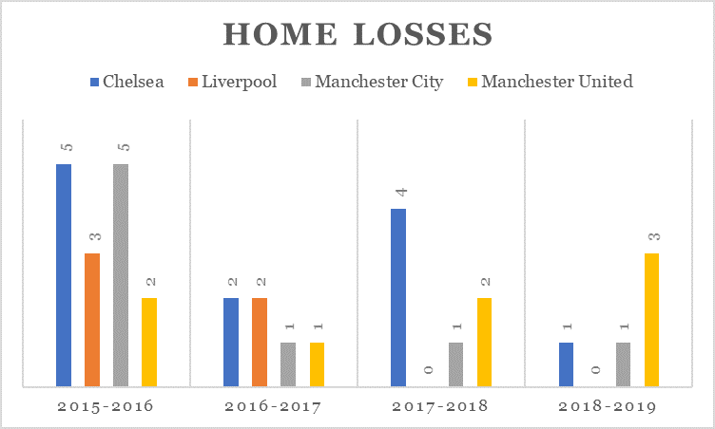

Same with the above analysis, Liverpool performed really strong at home and did not even lose a game in the past two seasons, but it is getting weaker and weaker on the road.

***Player Performance and Team Optimization***

* **Player Statistics:** A linear model is created to provide an evaluation on a single player’s *performance*. In the linear model, the coefficient Q represents the coaching style percentage and each variable represents a specific assessment on the player. For example, a player with strong *attacking* skill with a coach who values *attacking* skill a lot would have higher value of *Q1 * attacking.* This model is able to generate a performance score for each player.

*performance = Q1 * attacking + Q2 * skill + Q3 * movement + Q4 * power + Q5 * mentality + Q6 * defending + Q7 * goalkeeping*

* 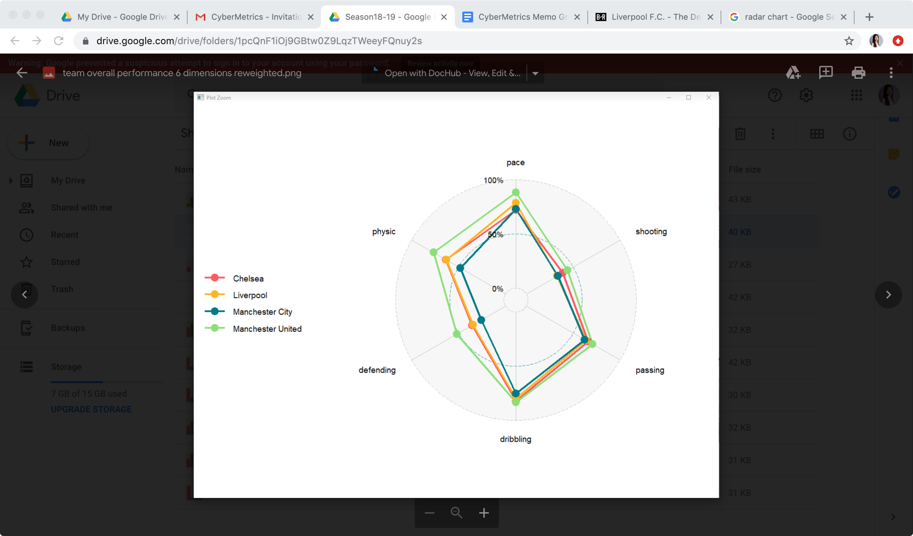**Team Weakness & Needs:** Each variable in the performance linear model was rescaled and normalized into 6 unique variables to assess the team’s overall performance. A radar chart is created for Liverpool and its competitors. For example, from the radar chart of 18-19 season, Liverpool could improve on defending and physic. Players who have a higher score on defending will compensate for the team’s weakness. Therefore, player trade and team needs will be evaluated later based on these two models.
* **Analysis on Cut/ Trade**: A player like Matthijs de Ligt from Juventus (Dudko, 2019) will complement the team, based on the above radar chart, given the following model results (*defending* = 83, and *physic* = 84). We see that Liverpool falls short of Manchester United by a significant percentage along these two variables.

The trade in of Sepp van den Berg (Hunter, 2019) confirms the needs of the team based on the model, with his *pace* = 68 will help to improve overall team performance which is less than 50% in this variable.

Slow players lower team performance. A player such as Adrián San Miguel del Castillo, although he was recently recruited, should be traded out of Liverpool; his *pace* = 45. Liverpool ranks second to Manchester United in this variable, with players such as Castillo contributing to this shortfall.

* **Analysis on Recruitment:** In order to be competitive, Liverpool must address its deficiencies in specific variables identified through our analysis as being significant. Based on the radar chart, Liverpool rates lowest in *shooting* (dropping from second in 16/17)and third in *passing*, *dribbling*, and *defending* as compared to its competitors, and will need to recruit players where these metrics are the highest contributors to overall performance.

***Next-Year Best Draft Pick***

From the result of evaluation based on value for money, we recommend that Koulibaly should be recruited by Liverpool to make up for the deficiency of *physic* (physical condition) and *defending* (defending power). Based on our model, Koulibaly’s *defending* values is 89, the same as Van Dijk, the central defender from Liverpool. Besides, his physical condition is also pretty good as a defender, a significant parameter showing that he can make full use of that and assist Van Dijk in “heading possession”. Furthermore, Koulibaly’s contract expires in 2021. After 2021, Liverpool will not be charged with a transfer fee from recruiting Napoli. Liverpool could use these funds to improve their backfield.

***Conclusion & Recommendation***

In summary, our recommendations will be:

1. Team manager Jurgen Klopp should use player rotation more frequently to keep the substitute players active during the season. At the same time, key players should rest to better manage their prolonged Premier League and UEFA Champions League schedules.
2. Historically Liverpool has performed better at home than away, often called the “Home Effect”. A more detailed analysis of player performance on away games can help to identify areas of improvement.
3. Last season, Jurgen Klopp focused primarily on All-in defending. Competitor teams have observed his strategy and have developed a counter game play. Klopp will need to focus more on strategies that implement *pace* and *dribbling* in order to remain competitive.